Final Case Study

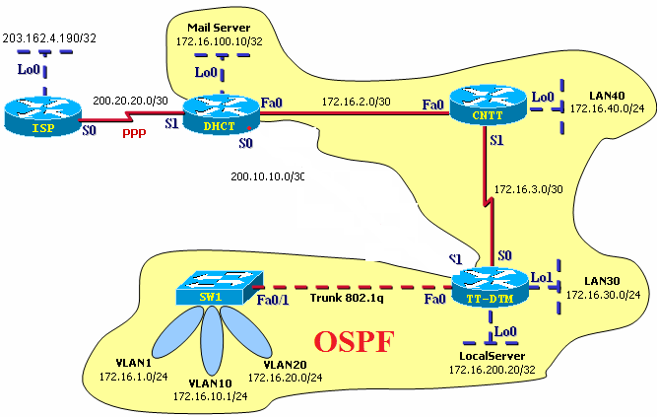

Basic Configuration
- Configure hostname, password (telnet, enable), ...
- Assign IP address on interfaces as above topology.
- Set clock rate on each DCE interface.
Configure Switch
- Create VLAN 10 (interfaces Fa0/5 and Fa0/6) with the name Student.
- Create VLAN 20 (interfaces Fa0/7 and Fa0/8) with the name Guest
Configure Inter-VLANs Trunking
- Setup Trunk between switch Sw1 and router TT-DTM.
- Setup inter-VLAN routing.
Configure OSPF
- Based on the border presented on topology configure OSPF on Routers.
Configure DHCP
- Configure DHCP on CNTT to provide IP addresses to LAN40, VLAN20
- Exclude the IP address of router interface.
- DNS server address is 203.162.4.190
Configure NAT services
- Configure NAT on router DHCT to provide Internet reach ability from Internet to your Web Server at IP address 200.20.20.5
- Configure PAT on router DHCT to translate inside host IP addresses to the outside public address of WAN interface.
Security
Set up ACL to deny access Internet from connection of VLAN10.

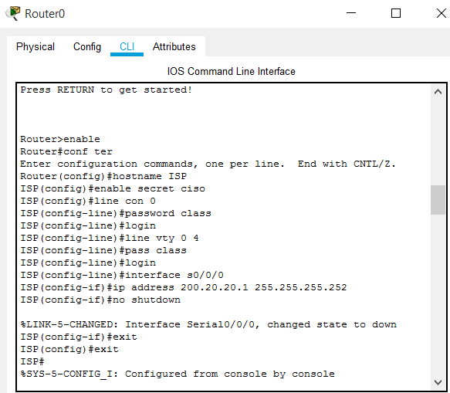
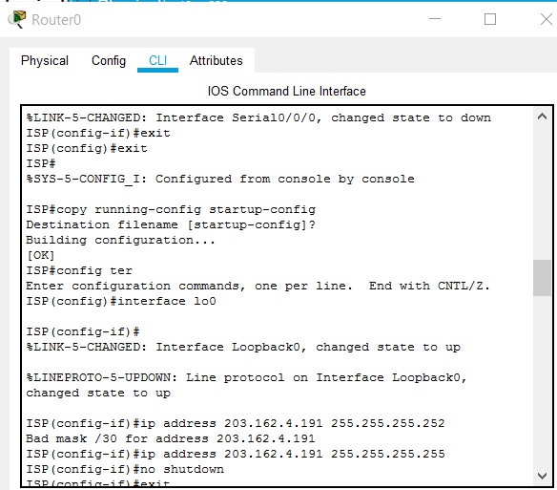
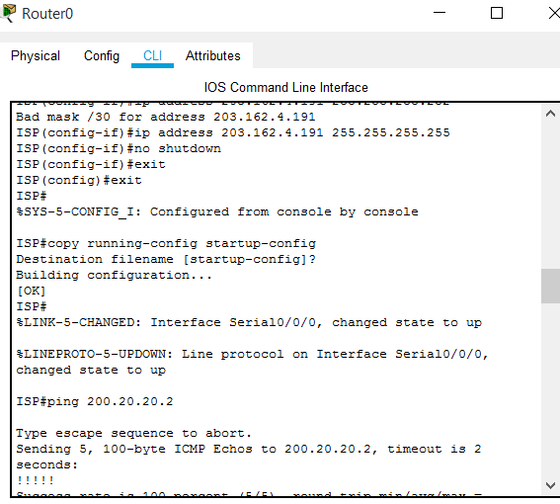
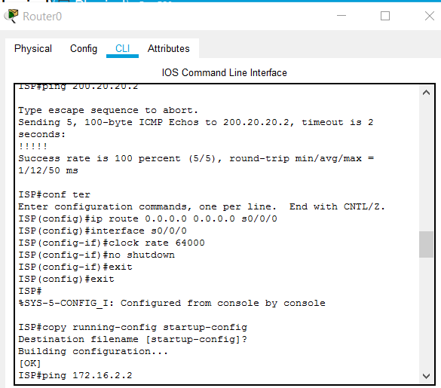

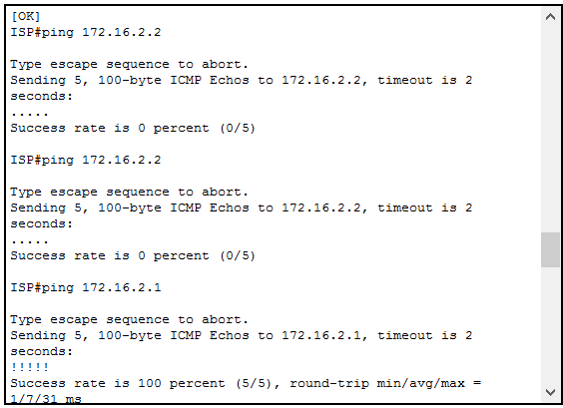

Router1
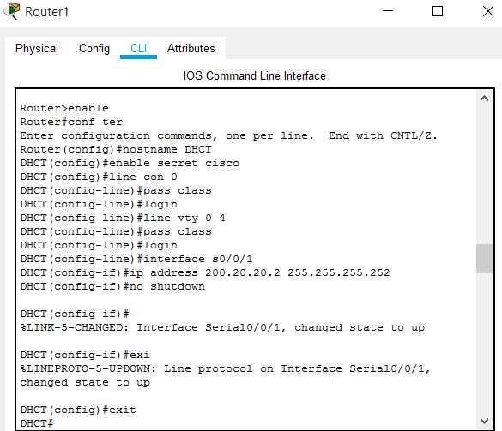
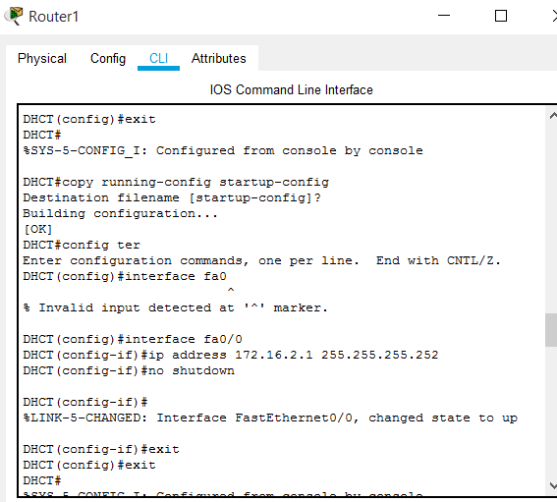
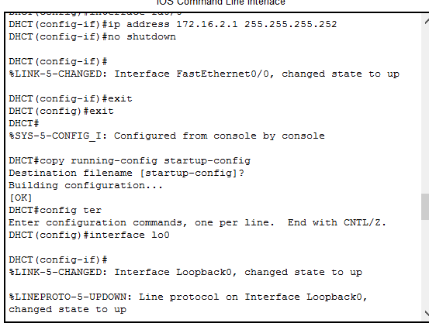
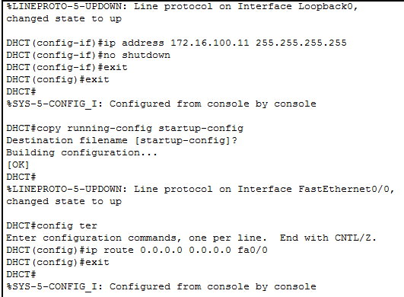

R3
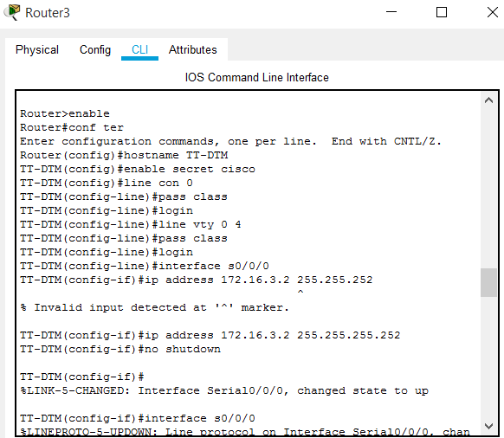
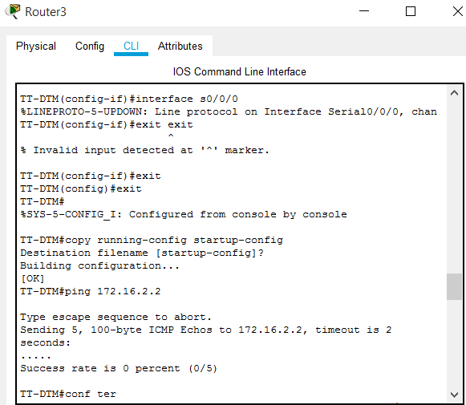
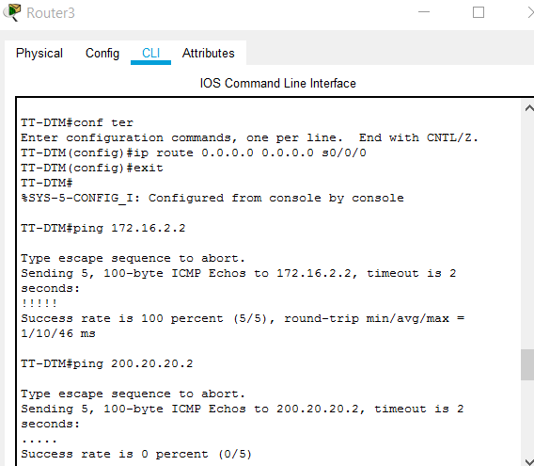
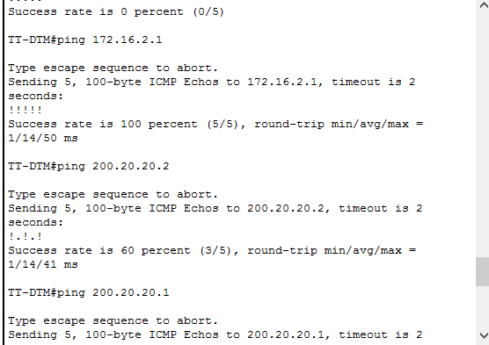
R2
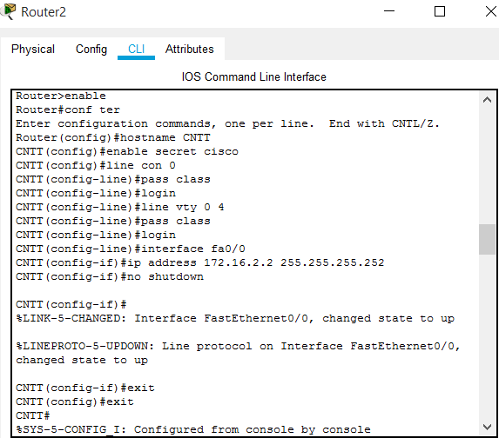
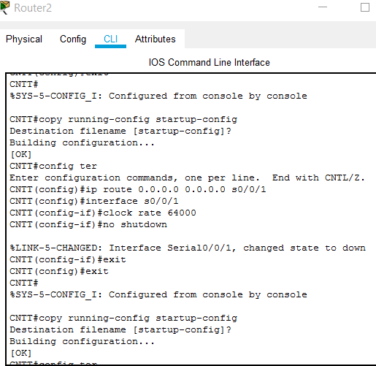
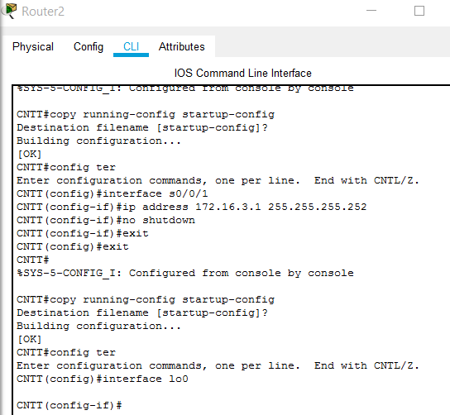
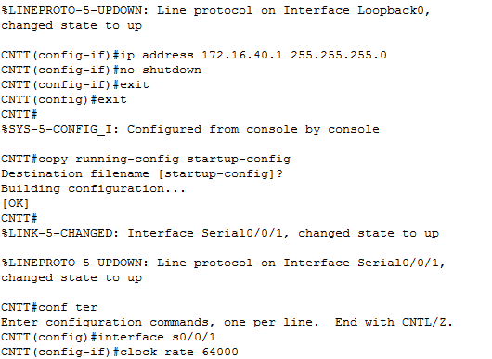
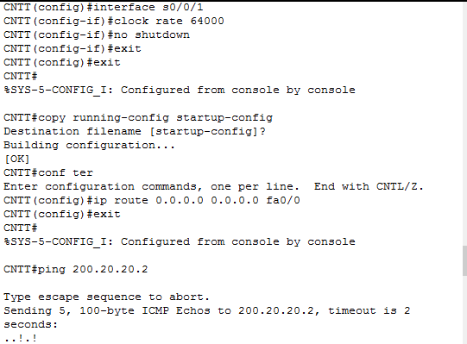
Cau hinh RIP (khác ip route ở trên)

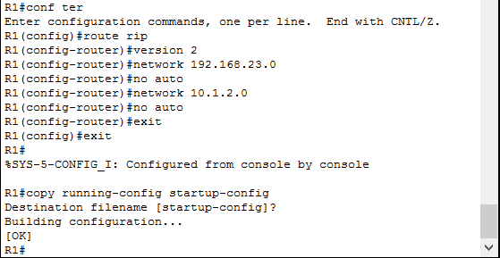
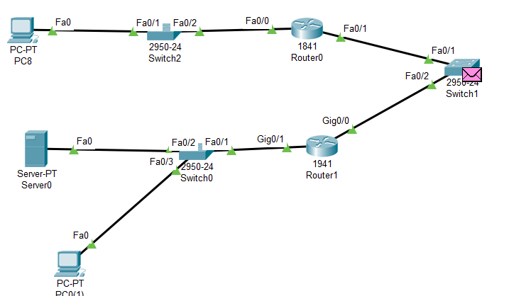

VLAN
Đặt tên, vẽ hình lại
